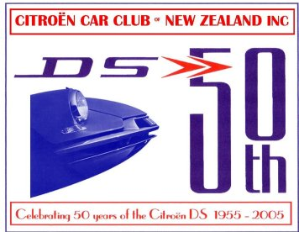

VEHICLE INFORMATION:

Model _________________________________ Year: ___________________________________

Colour: ­­­_________________________________ Registration Number: ______________________

Driver(s): __________________________________________________________________________

Address: ___________________________________________________________________________

Phone: Home: ­­­­_____________________________ Cell: __________________________________

Email: ____________________________________________________________________________

Passenger Names: (required for name tags}_______________________________________________

__________________________________________________________________________________

I /We will be doing the full D Tour YES / NO

I / We will be doing the North Island Section Only YES / NO

I / We will be doing the South Island Section Only YES / NO

If you are not planning on doing the full D Tour or one of the full Island Tours please let us know where you plan to join the tour: __________________________________________________

Do you want to do the trip the Cape Reinga on Thursday? YES / NO

**Registration Expenses:** Tour Packs $80

**Payment can be made by cheque ( please make out to “Citroen DS 60” ) and mail to:**

Citroen DS Anniversary,

**Electronic payments can be made directly to out bank account :**

**Payment to Name: DS 60, Ref: “Tour Rego”. Please do not forget to include your name.**

**CITROEN DS 60TH CELEBRATION TOUR**

**0CTOBER 22 – 29 2015**

**REGISTRATION FORMS**

**REGISTRATIONS CLOSE MAY 30 2015**

**By signing this registration form you agree to the following:**

**I / We acknowledge that I / We will be participating in the DS 60th Celebration Tour at my / our own risk.**

**The event organisers shall not accept responsibility or liability in the event of loss, injury or damage to persons or property arising while engaged in the event.**

**SIGNED: ____________________________________**

**DATED : _____________________________________**

**This form can be mailed to :**

**Or emailed to: ds23ie@gmail.com.**