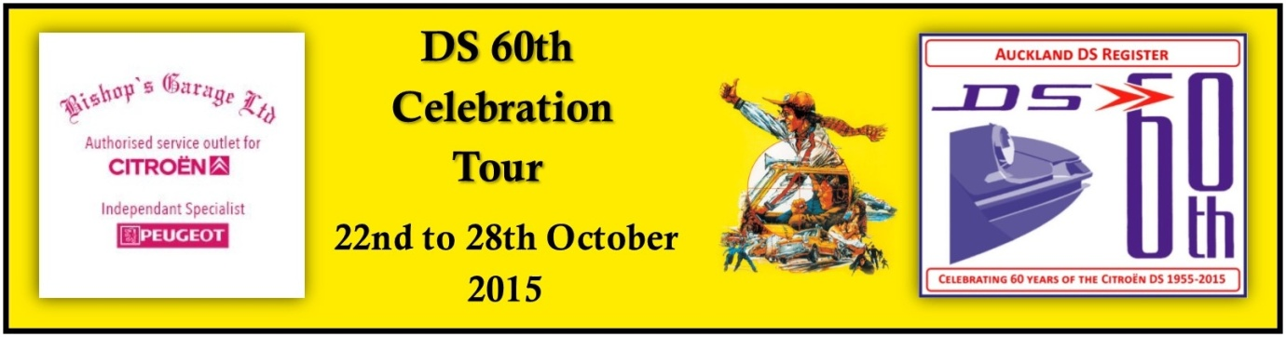

DAY TWO DS 60th CELEBRATION TOUR/ TOURTIERE ADIEU
Saturday 24 October 2015.
Day’s Details.
1. Gather at Shed 16 at 8.30 for breakfast.
2. Depart Drury on the first leg of a long day’s drive. We will head south on HW 1 which we will leave at Pokeno for a photo stop outside the GAS station. Then back onto the Southern Motorway until we arrive at Taupiri, a few km’s south of Huntly. At Taupiri you will need to make your first decision for the day, which route would you prefer to take.
a -Either along HW 1, the new expressway to Hamilton and then along the Hamilton bypass around the western side of Hamilton back on to HW 1 south
b – or follow HW 1B through rural countryside until you reach Cambridge and once again join HW 1 south towards Taupo.
3. The first leg will finish at Wairakei where we will stop for lunch and a rest. The petrol station has a place to eat. You may wish to drive into Taupo for lunch and continue south to Turangi.
4. After lunch we begin the second leg of the day. We will proceed to the start of the Taupo bypass then south on Highway 1 to Turangi. A few km’s south of Turangi we take a right turn onto HW 46, Lake Rotoaira Rd and then left onto HW 47 to National Park.
5. You may wish to make a quick stop at the GAS petrol Station at National Park for a photo shoot.
6. Then on to a quick stop at Horopito. We will try to organise a photo stop with a sad ID at Horopito Motors.
7. This is the last planned stop until we reach Whanganui our overnight stop.

Points of Interest.

