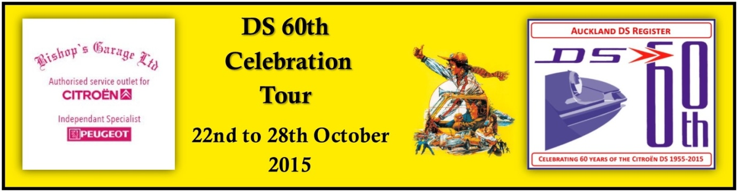

DS 60th Tour / Tourtiere Adieu
Kaitaia to Cape Reinga and return.
Thursday 22 October 2015.
Day’s Details.
1. Gather at The Northener Hotel carpark around 9.00am
2. Depart Kaitaia for Cape Reinga via Awanui and HW 1.
3. Photos at the Cape.
4. On return to Kaitaia possible trip out to Ahipara and a game of Spheres at the beach.
5. Gather in ………….. at 8.00pm for an introduction to the tour and the handing out of Tour packs.

